Module 3: Homework 2 Assignment: MySQL and Cloud Spanner in GCP

**1st assignment**:  **Using** **Cloud SQL Admin API.**

* Steps to create an Instance.
  + Search and enable Cloud SQL Admin API
    - Click the "Search for APIs & Services" field. And search for Cloud SQL Admin.
    - Click " Cloud SQL Admin API "A screenshot of a computer

      Description automatically generated
    - Click “Enable”  
      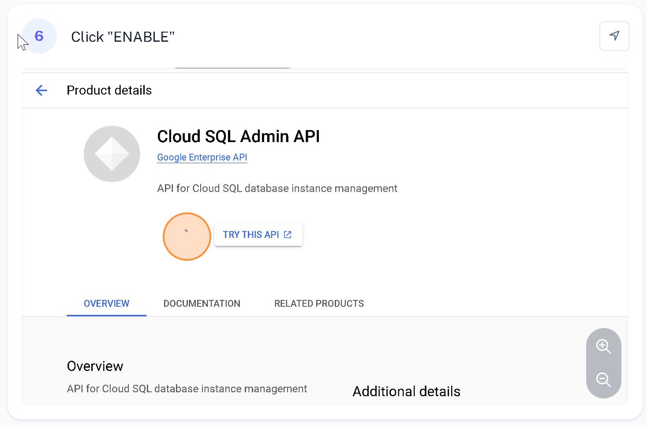
    - Cloud SQL instance > Go to Cloud and Click "CREATE INSTANCE" and select MYSQL  
      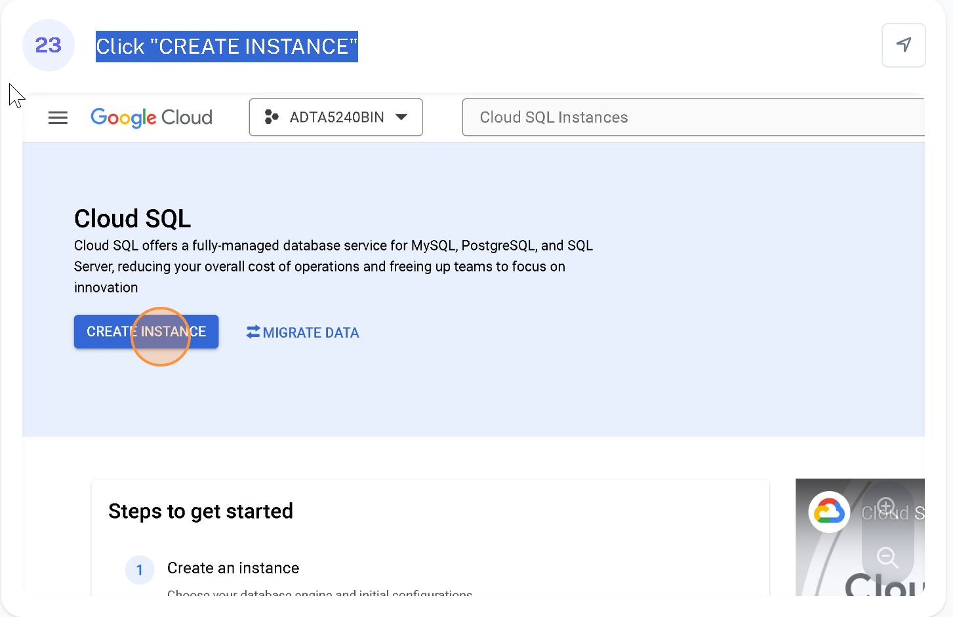
    - Click the "Instance ID" field.
    - Type "my­Instance" in Instance id filed.
    - Enter a password for the root user.
    - Click "CREATE INSTANCE"

* Steps you took to create a database.
  + Open Cloud Shell.
  + gcloud sql connect my­Instance --user=root
  + use root Password used earlier.  
      
    A screen shot of a computer

    Description automatically generated
  + Create New Database
    - CREATE DATABASE customers;
  + Set the Database to customers
    - USE customers;
  + Create TABLE

CREATE TABLE customers

(fName VARCHAR(255),

lName VARCHAR(255),

phone VARCHAR(255),

address VARCHAR(255),

city VARCHAR(255),

state VARCHAR(255),

model VARCHAR(255),

comments VARCHAR(255));

* Steps to load the data.
  + Use INSERT INTO table_name (column1, column2, column3, ...) VALUES (value1, value2, value3, ...);
    - INSERT INTO customers (fName, lName, phone, address, city, state, model, comments) values ("Tony", "Barone", "555-676-7778","1018 State Street", "Houston", "TX", "A-1237", "This is the best product I have ever purchased.");
    - INSERT INTO customers (fName, lName, phone, address, city, state, model, comments) values ("Helen", "Smith", "777-879-0098", "889 Elm Road", "St. Louis", "MO", "H-435", "I would never buy this product again!");
    - INSERT INTO customers (fName, lName, phone, address, city, state, model, comments) values("Susan", "Heller", "876-888-6795", "879 Main Street", "Los Angeles", "CA", "K-8887", "All good");
    - INSERT INTO customers (fName, lName, phone, address, city, state, model, comments) values("Betsy", "Clark", "555-887-1098", "45 West 54th Ave.", "Topeka", "KS", "Z-2", "No issues");

* Steps to show the table.
  + See inserted table using SELECT * FROM customers;

**2nd assignment using Cloud Spanner.**

* Enabling Cloud Spanner API and Creating Instance.
  + Search and enable Cloud Spanner API and Click "Cloud Spanner API"  
    A screenshot of a computer

    Description automatically generated
  + The Enable the API  
    A screenshot of a computer

    Description automatically generated
  + Create Instance
    - Open Cloud Shell.
    - Set to your project > gcloud config set project adta5240bin
    - Check instance running in the spinner > gcloud spanner instance-configs list

* + - Create an instance > gcloud spanner instances create test-instance --config=regional-us-central1 --description="My Instance" --nodes=1

* + - Set the default instance > gcloud config set spanner/instance test-instance

* Steps to create a dataset and the two tables.
  + Create database > gcloud spanner databases create example-db

* + Create table >
    - Table 1 > gcloud spanner databases ddl update example-db \--ddl='CREATE TABLE Singers ( SingerId INT64 NOT NULL, FirstName STRING(1024),LastName STRING(1024), SingerInfo BYTES(MAX) ) PRIMARY KEY (SingerId)'
    - Table 2 > gcloud spanner databases ddl update example-db \--ddl='CREATE TABLE Albums ( SingerId INT64 NOT NULL, AlbumId INT64 NOT NULL,AlbumTitle STRING(MAX)) PRIMARY KEY (SingerId, AlbumId), INTERLEAVE IN PARENT Singers ON DELETE CASCADE'

* Steps to insert the data.

gcloud spanner rows insert --database=example-db --table=Singers --data=SingerId=1,FirstName=Marc,LastName=Richards

gcloud spanner rows insert --database=example-db --table=Singers --data=SingerId=2,FirstName=Catalina,LastName=Smith

gcloud spanner rows insert --database=example-db --table=Albums --data=SingerId=1,AlbumId=1,AlbumTitle="Total Junk"

gcloud spanner rows insert --database=example-db --table=Albums --data=SingerId=2,AlbumId=1,AlbumTitle="Green"

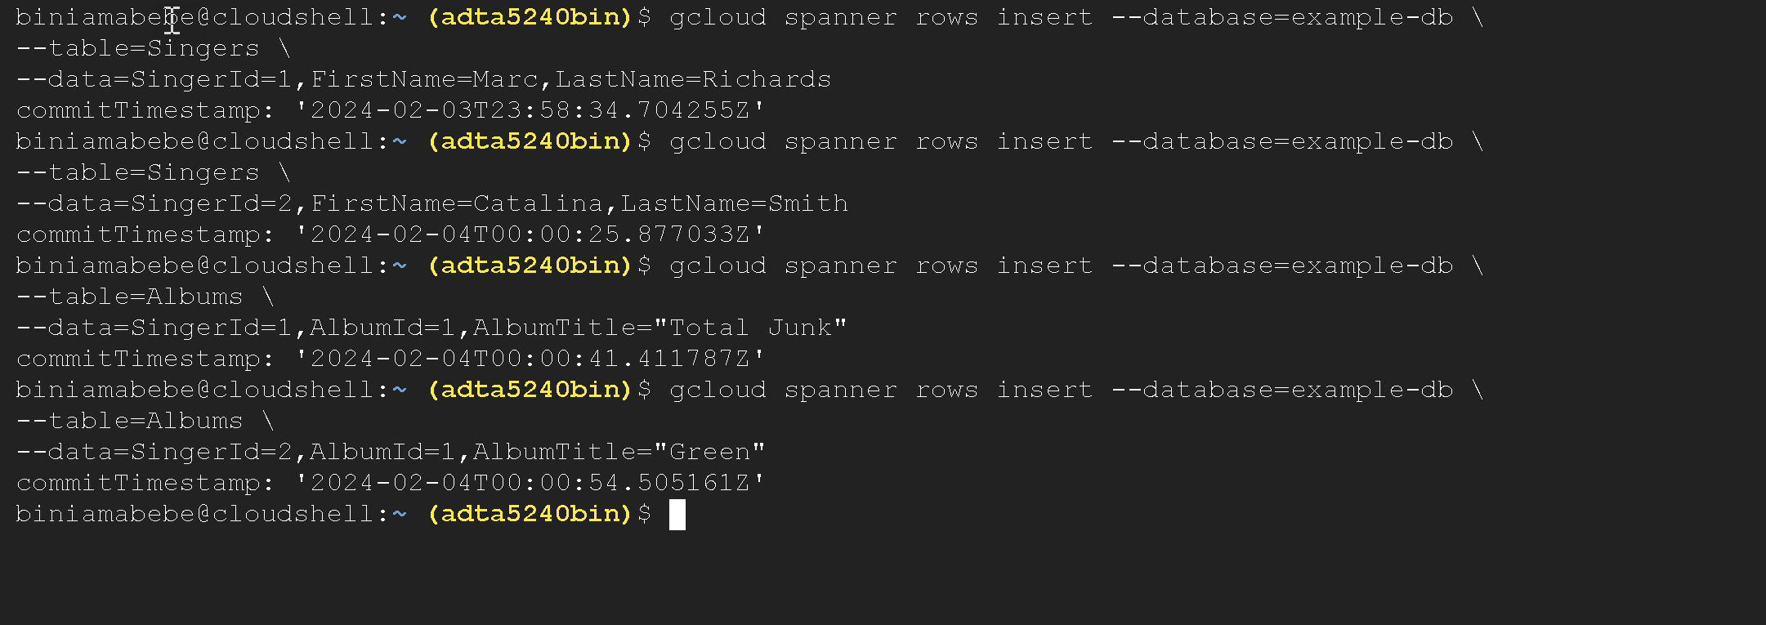

* Steps to show the tables.
  + Go to Spanner from the consol
  + Open Editor window and write > Select * from Singers
  + Open Editor window and write > Select * from Albums

